EXPERIMENT NO. 01

Natural Language Processing for Enhancing Teaching and Learning

NAME: ATIF UMAR THAKUR
ROLL NO: 14DCO69

INTRODUCTION:

Advances in natural language processing (NLP) and educational technology, as well as the availability of unprecedented amounts of educationally-relevant text and speech data, have led to an increasing interest in using NLP to address the needs of teachers and students. Educational applications differ in many ways, however, from the types of applications for which NLP systems are typically developed. This paper will organize and give an overview of research in this area, focusing on opportunities as well as challenges.

Teaching about Language

One of the oldest yet still very active educational application areas for NLP involves language assessment. Summative language assessment typically involves evaluating student proficiency in reading, writing, or speaking a first or second language (e.g., grading an essay as in in automated essay scoring (Shermis and Burstein 2013)) as an end in itself. Formative language assessment, in contrast, typically evaluates student work to support downstream activities such as human or machine tutoring to improve current proficiency.

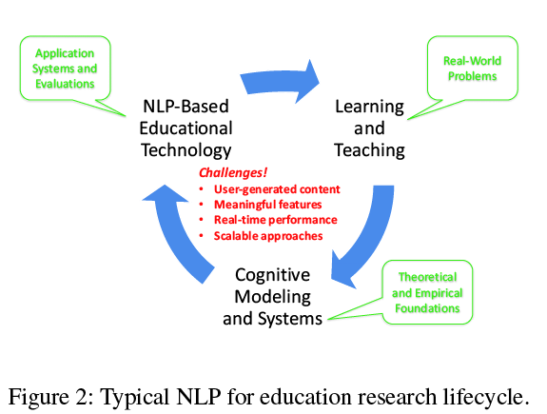

Teaching using Language

Primarily with teachers in mind, NLP is being used to try to automate tasks that traditionally have required manual effort,e.g., creating curriculum or assessment materials. NLP methods can be used to support fine-grained personalization of curriculum materials by automatically finding materials from electronic sources such as the web that are particularly tailored to a student’s reading level and/or topics of interests (Miltsakaki and Troutt 2008; Pitler and Nenkova 2008; Petersen and Ostendorf 2009; Heilman et al. 2007). Semantic similarity shows promise in identifying core concepts from science education resources (Sultan, Bethard, and Sumner 2014), while text simplification is being studied as a method for enabling the reuse of existing materials across student proficiency levels (Candido Jr et al. 2009). With respect to assessment, NLP-based methods for automatically generating multiple-choice, wordbank, and other types of test questions by processing texts in the subject domain are being explored (Brown, Frishkoff, and Eskenazi 2005; Mitkov, Ha, and Karamanis 2006; Heilman and Smith 2010). For students, NLP is being used to help them better navigate text and speech-based course related materials. For example, knowledge of speech has been used to develop tools that allow students to better access and process external online lecture materials related to course content (Glass et al. 2007).With researchers in mind, NLP is being used to mine educationally-relevant language data in order to provide an empirical basis for system design (recall the bottom of Figure2). As discussed at the end of the prior section, my own work developed methods to process existing humanhuman, human-computer, and even computer-computer dialogue corpora between tutors and students, in order to gain insights for (or in some case to actually automate) the authoring of our tutorial dialogue system. Communities focused on tailoring data mining algorithms to address the special needs of educational (including NLP-based) research in just this way have recently emerged.

Processing Language

In addition to assessing student linguistic inputs and serving as a medium of instruction, a third role for NLP in education is to usefully process text and speech in any other way that can support students and teachers as well as researchers and system developers. This NLP role takes advantage of an ever increasing amount of electronically available text and speech, e.g., as found in social media, personal blogs and websites, in Wikipedia and online textbooks, in lecture slides and videos, in logs from MOOC tools such as discussion forums, chat rooms, and peer review systems, in linguistic data repositories such as the Linguistic Data Consortium (http://www.ldc.upenn.edu/), and so on. Primarily with teachers in mind, NLP is being used to try to automate tasks that traditionally have required manual effort, e.g., creating curriculum or assessment materials. NLP methods can be used to support fine-grained personalization of curriculum materials by automatically finding materials from electronic sources such as the web that are particularly tailored to a student’s reading level and/or topics of interests (Miltsakaki and Troutt 2008; Pitler and Nenkova 2008; Petersen and Ostendorf 2009; Heilman et al. 2007). Semantic similarity shows promise in identifying core concepts from science education resources (Sultan, Bethard, and Sumner 2014), while text simplification is being studied as a method for enabling the reuse of existing materials across student proficiency levels (Candido Jr et al. 2009). With respect to assessment, NLP-based methods for automatically generating multiple-choice, wordbank, and other types of test questions by processing texts in the subject domain are being explored (Brown, Frishkoff, and Eskenazi 2005; Mitkov, Ha, and Karamanis 2006; Heilman and Smith 2010). For students, NLP is being used to help them better navigate text and speech-based course related materials.For example, knowledge of speech has been used to develop tools that allow students to better access and process externalonline lecture materials related to course content (Glasset al. 2007). With researchers in mind, NLP is being used to mine educationally-relevant language data in order to provide an empirical basis for system design (recall the bottom of Figure 2). As discussed at the end of the prior section, my own work developed methods to process existing humanhuman, human-computer, and even computer-computer dialogue corpora between tutors and students, in order to gain insights for (or in some case to actually automate) the authoring of our tutorial dialogue system. Communities focused on tailoring data mining algorithms to address the special needs of educational (including NLP-based) research in just this way have recently emerged. In 2011 the International Educational Data Mining Society11 was formed; after the emergence of MOOCs, an ACM ‘Learning at Scale’12 conference series was launched in 2014.

Evaluation

Much current NLP research for education is evaluated only intrinsically, typically by comparing the output of an isolated NLP program to a human gold-standard. Extrinsic evaluations of educational technologies that incorporate such NLP components are much rarer. Extrinsic evaluations conducted in authentic educational contexts such as classrooms rather than in laboratory settings are rarer still. Furthermore, current NLP methods are often tailored to data from particular contexts (e.g., scoring responses to specific essay prompts, processing language from students of only certain ages, tutoring in well-formed STEM domains such as qualitative physics). As NLP capabilities continue to improve and become increasingly incorporated into larger educational technologies, extrinsic evaluations will also become increasingly important. Such evaluations will be useful for determining the tolerance of educational technologies to the amount and types of NLP errors, for evaluating whether developed methods can generalize across students, teachers, courses, schools, etc., and for fostering richer collaborations between NLP and educational researchers.

CONCLUSION:

This paper has presented a summary of research in the area of NLP for educational applications. Such research is motivated by addressing the needs of teachers and learners, andtechnically constrained to respect the special requirements of educational data and algorithms. Although education is arguably one of the oldest application areas of NLP research, new phenomena such as MOOCs and big data have triggered an explosion of current interest in this area, as well as increased already strong ties between researchers in NLP and in other areas of Artificial Intelligence. The paper began by presenting a framework for synthesizing the literature in terms of an iterative research lifecycle. This was followed by a summary of the literature, organized in terms of three major roles that NLP has played in educationalresearch: assessing language, using language, and processing language. Opportunities and challenges for innovative NLP research were highlighted throughout the paper.

